


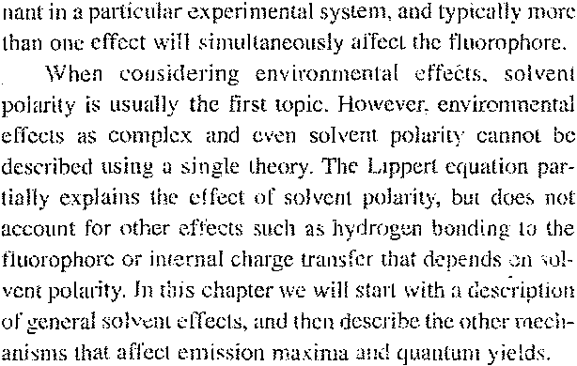
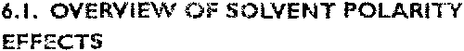
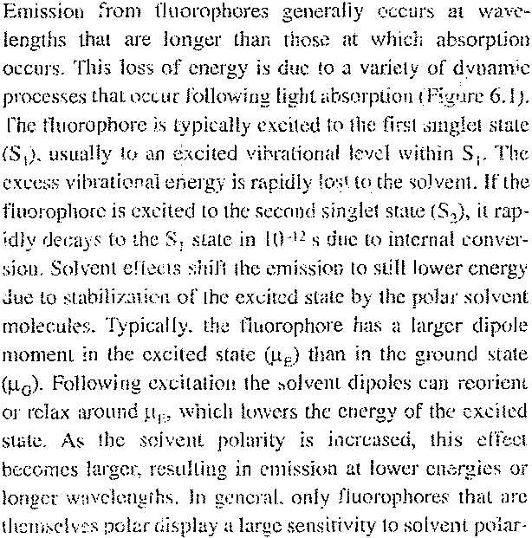
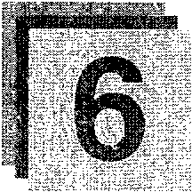
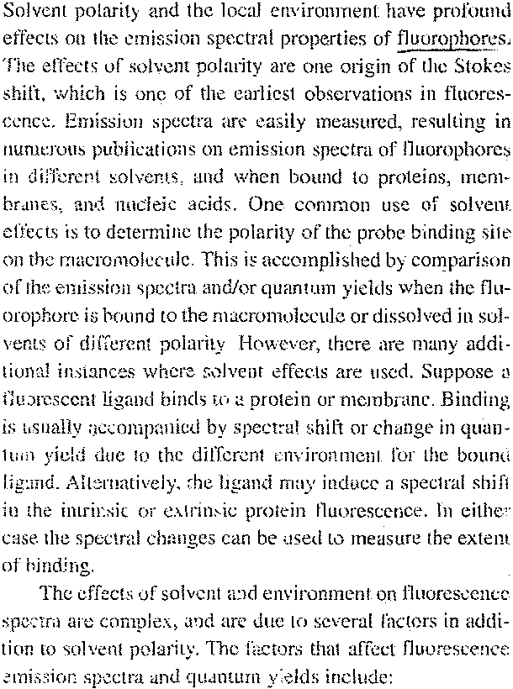
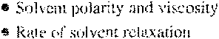
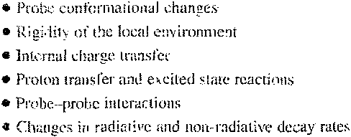
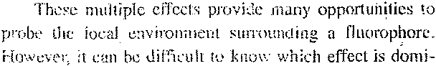

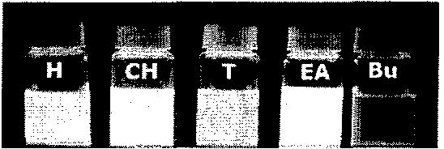
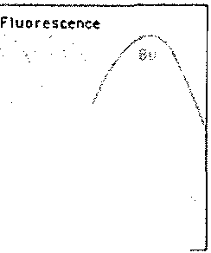
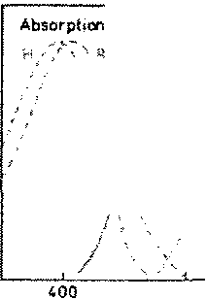
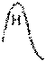
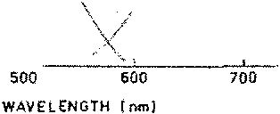
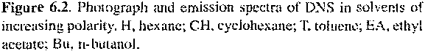
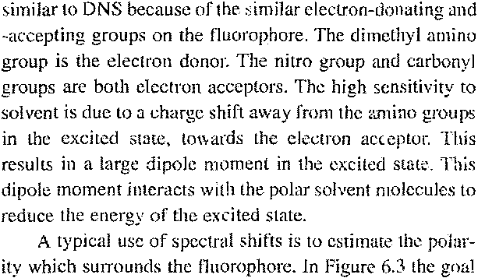
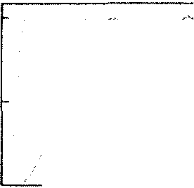
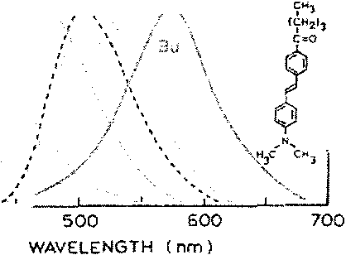
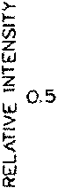
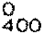
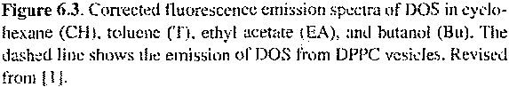
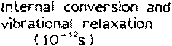
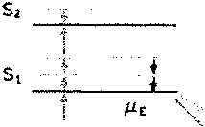
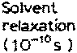
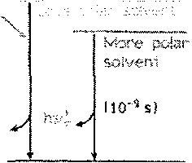
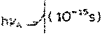
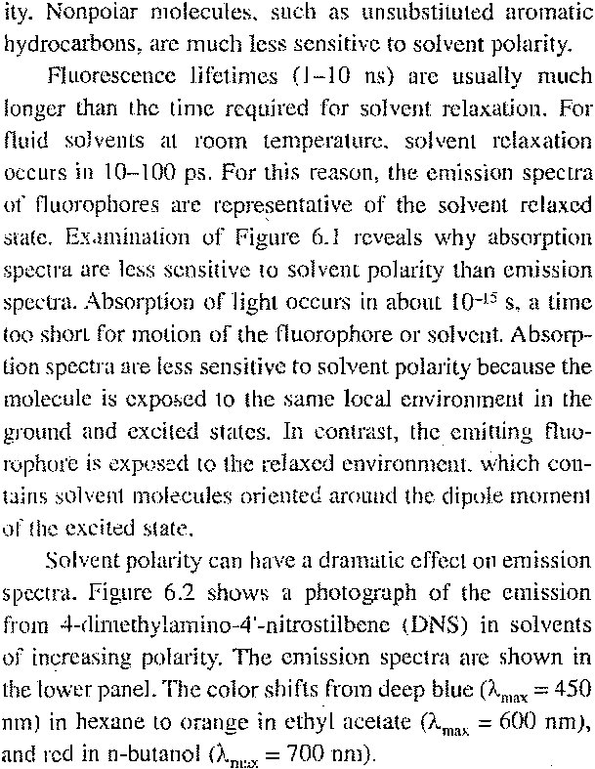
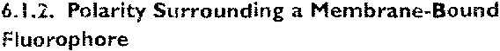
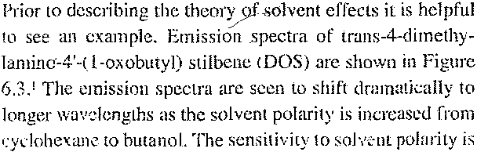

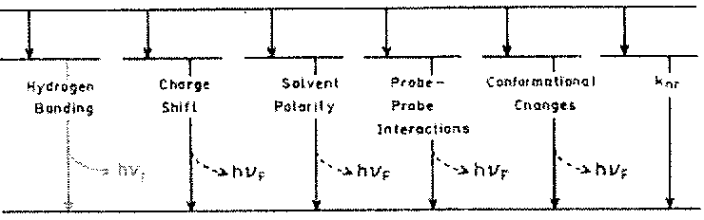
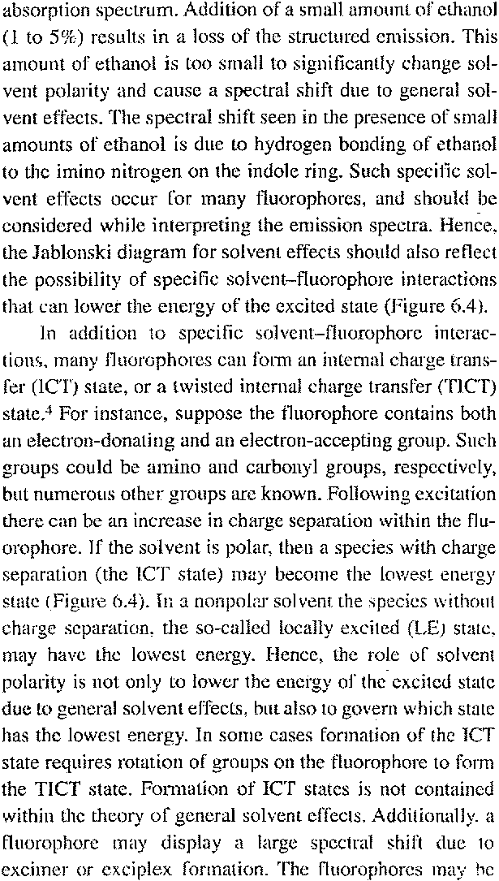
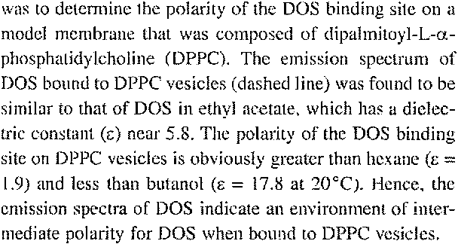
‏ While interpretation of solvent—dependent emission spectra appears simple, this is a very complex topic. ‘The complexity is due to the variety of interactions that can result in spectral shifts. At the simplest level, solvent-dependent emission spectra are interpreted in terms of the Lippert equation (eq. 6.1, below), which describes the Stokes shifts in terms of the changes in dipole moment which occur upon excitation, and the energy of a dipole in solvents of various dielectric constant (ε) or refractive index (n).²⁻³ These general solvent effects occur whenever a fluorophore is dissolved in any solvent, and are independent of the chemical properties of the fluorophore and the solvent.
The theory for general solvent effects is often inadequate for explaining the detailed behavior of fluorophores in a variety of environments. This is because fluorophores often display multiple interactions with their local environments, which can shift the spectra by amounts comparable to general solvent effects. For instance. indole displays a structured emission in the nonpolar solvent cyclohexane (see Figure 16.5). This spectrum is a mirror image of its

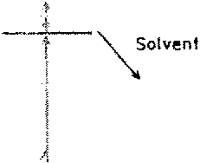
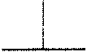

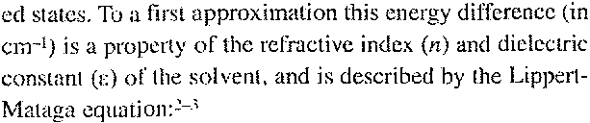
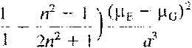
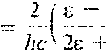
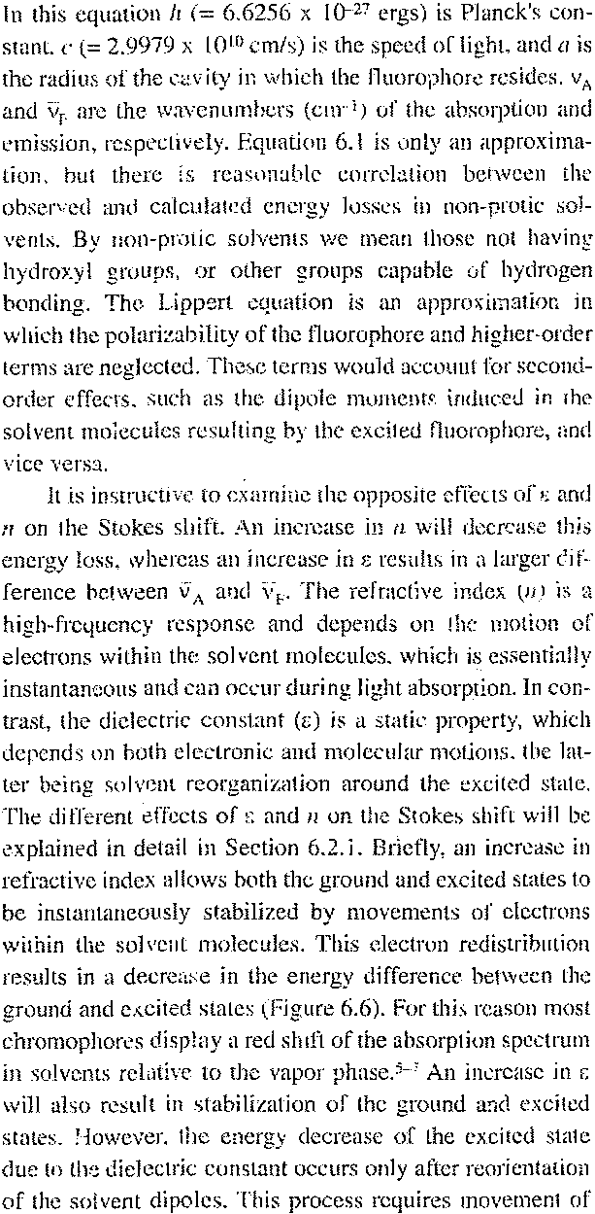
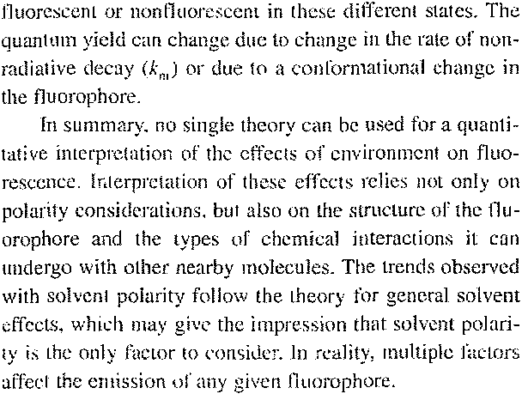
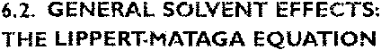
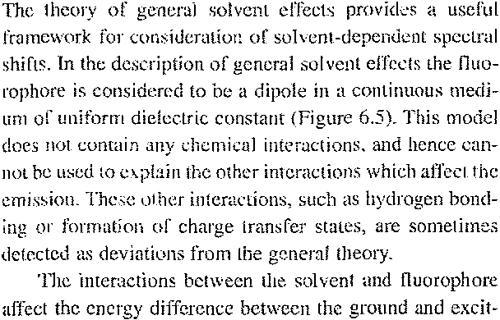
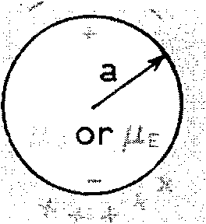
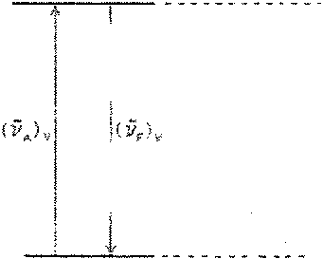
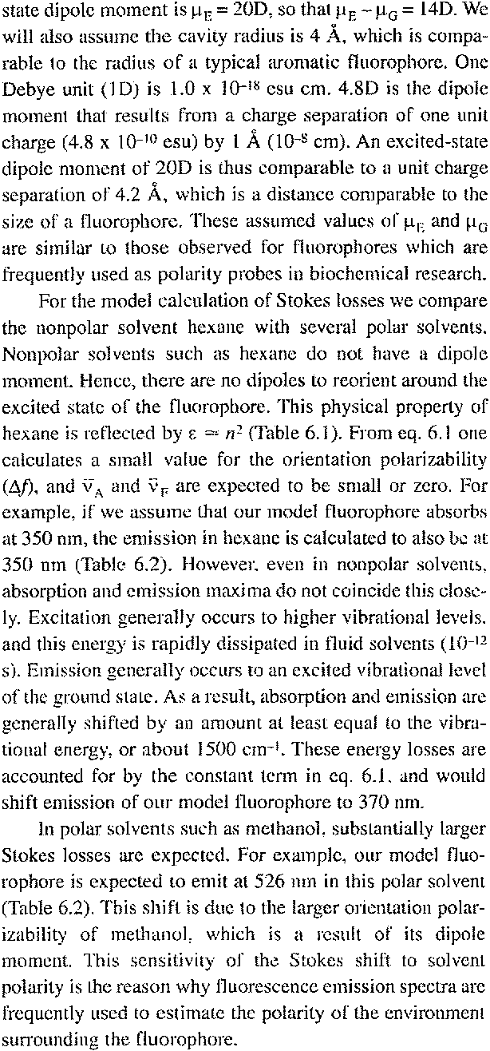
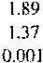
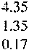
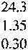
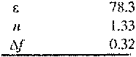

‏ the entire solveni molecule, not just its electrons. As a result, stabilization of the ground and excited states of the fluorophore depends on the dielectric constant (ε) and is time dependent. The rate of solvent relaxation depends on the temperature and viscosity of the solvent (Chapter 7). The excited state shifts to lower energy on a timescale comparable to the solvent reorientation time. In the derivation of the Lippert equation (Section 6.2.1), and throughout this chapter, it is assumed that solvent relaxation is complete prior to emission.
The term inside the large parentheses in eq. 6.1 is called the orientation polarizability (Δf ).The first term (ε — 1)/(2ε + 1) accounts for the spectral shifts due to both the reorientation of the solvent dipoles and to the redistribution of the electrons in the solvent molecules (Figure 6.6, center). The second term (n² — 1)/(2n² + 1) accounts for only the redistribution of electrons. The difference of these two terms accounts for the spectral shifts due to reorientation of the solvent molecules (Figure 6.6, right), and hence the term orientation polarizabilrty. According to this simple model, only solvent reorientation is expected to result in substantial Stokes shifts. The redistribution of electrons occurs instantaneously, and both the ground and excited states are approximately equally stabilized by this process. As a result, the refractive index and electronic redistribution has a comparatively minor effect on the Stokes shift.
It is instructive to calculate the magnitude of the spectral shifts that are expected for general solvent effects. Most fluorophores have nonzero dipole moments in the ground and excited states. As an example we will assume that the ground-state dipole moment is μ_{G} =6D, and the excited-

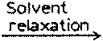

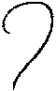
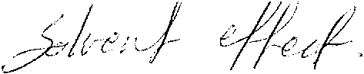
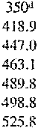
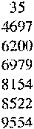
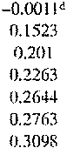
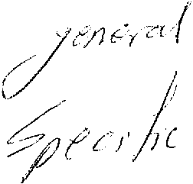
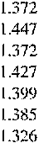
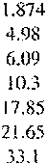
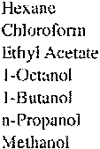
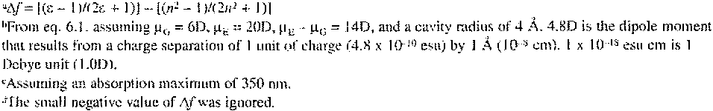
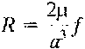
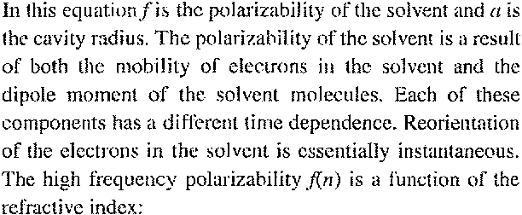
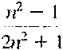
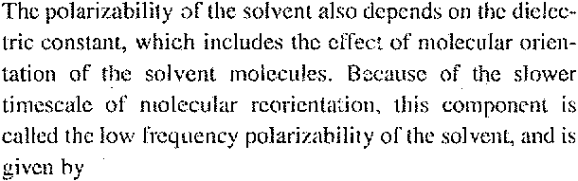
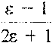
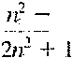
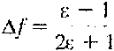
The difference between these two terms is

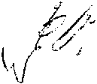
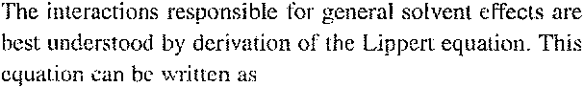
‏م لزك 2
‏اة ءمه 8 ‏أاءها - ،ها) 00 ‏.ر
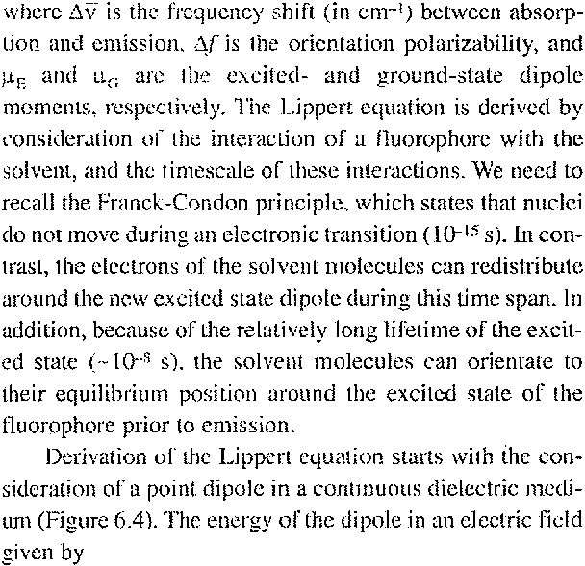
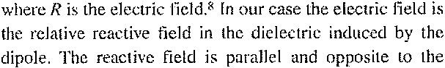

‏م م م ر.روم ر_رمدم:دم م.،-
‏ى.<>، - يلا<« - : 7 ‏-
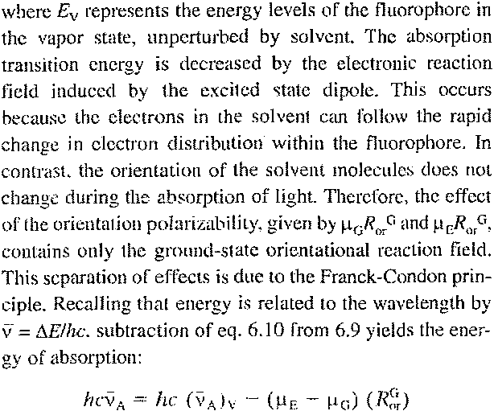
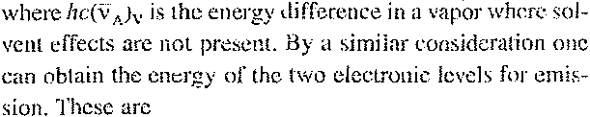
‏._ 7 ‏،<إ - م كاا:. ام - لإ.) - ذااءأ 0 ‏أ.أاءنا ا~_»ءاا. 1
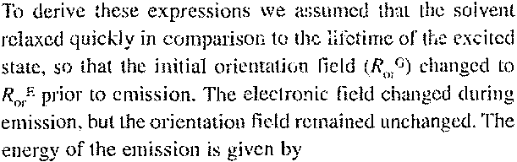
0 ‏»> .ء» لإ_م.م : يلا.«م ،~ رلاد(.دم - _،م ر - ..«>.م<>).» - ..ت.<.<
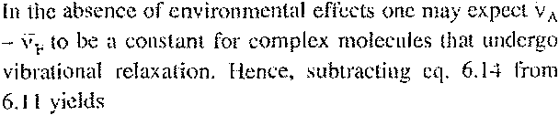
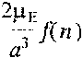
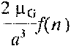
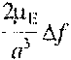
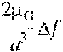
Consider Figure 6.7. which describe these fields during the processes of excitation and emission . For light absorption the energies of the ground (E^{G}) and nonequilibrium excited (E^{E}) states are

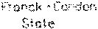
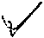
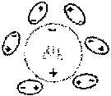
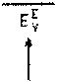

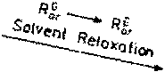
and is called the orientation polarizability. If the solvent has no permanent dipole moment. ε=n² and Δf 0.
Table 6.1 lists representative values of ε, n and Δf . From the magnitudes of Δf one may judge that spectral shifts Δν will be considerably larger in water than in hexane. The interactions of a fluorophore with solvent can be described in terms of its ground- (μ_{G}) and excited-stale (μ_{E}) dipole moments, and the reactive fields around these dipoles. These fields may be divided into those due to electronic motions ( R_{el}^{G} and R_{el}^{G}) and those due to solvent reorientation (R_{el}^{G} and R_{el}^{G}).Assunung equilibrium around the dipole moments of the ground and excited states, these reactive fields are
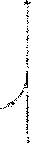
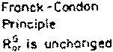
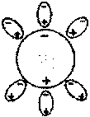
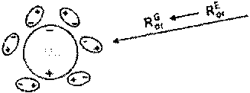
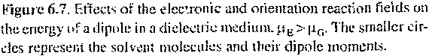

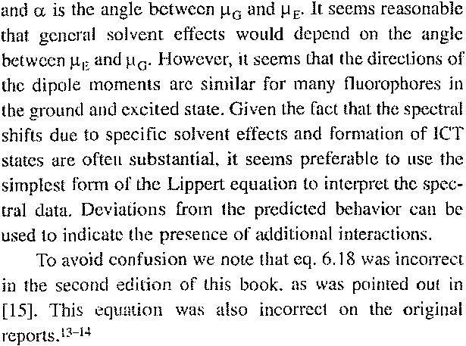
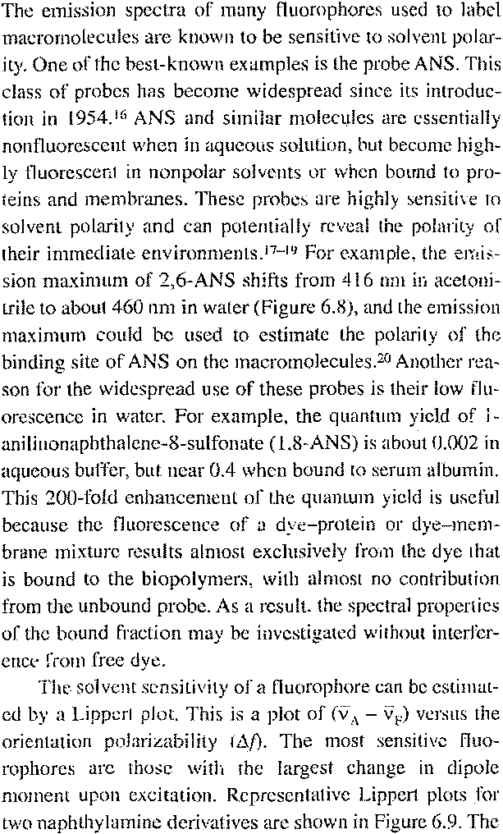
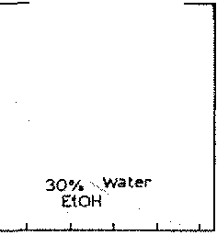
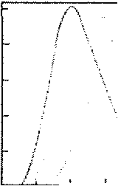
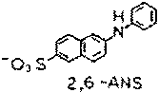
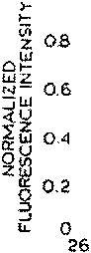
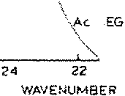
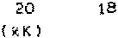
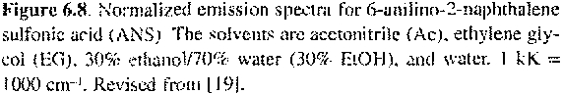
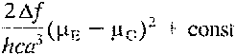
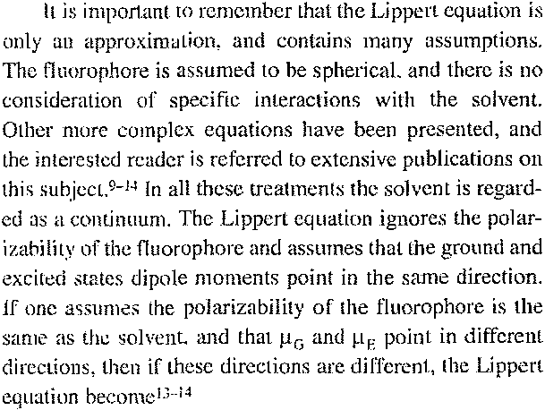
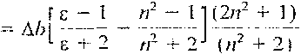
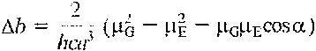

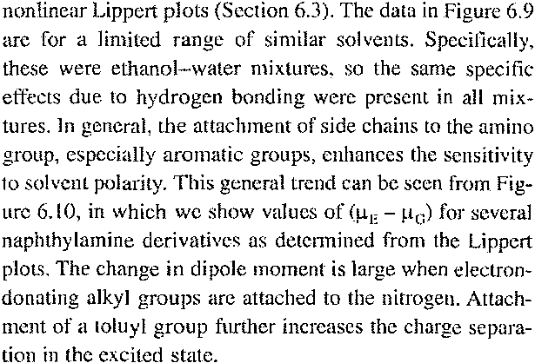
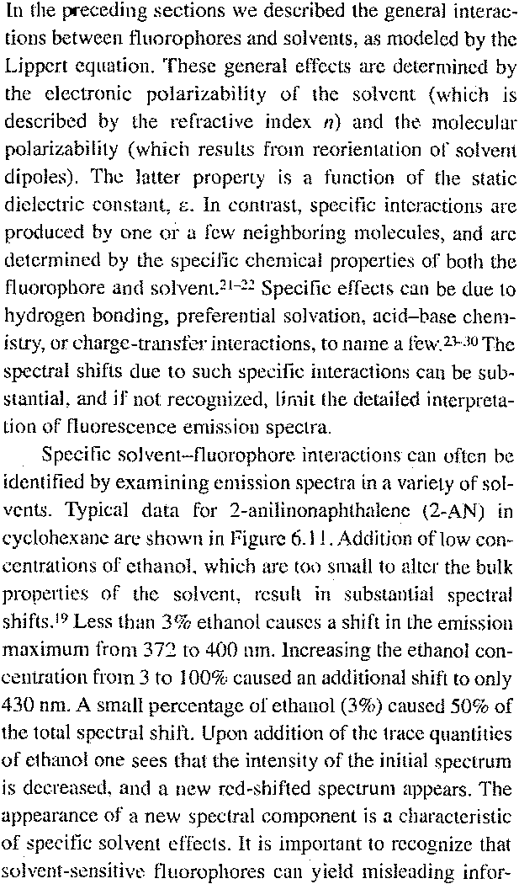
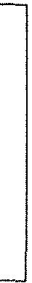
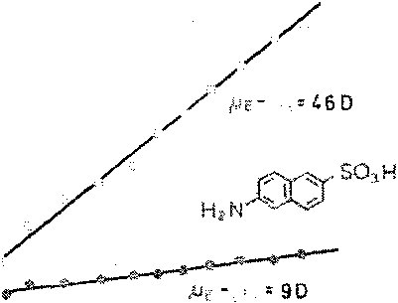
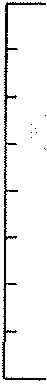
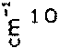
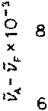
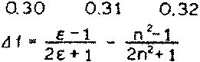
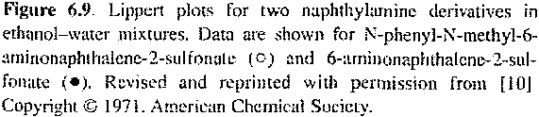
‏sensitivity of these fluorophores to solvent polarity is probably due to a charge shift from the amino group towards the electronegative sulfonic acid group. The N-phenyl-Nmethyl derivative of 6-aminonaphthalenc-2-sulfonic acid is more sensitive to solvent polarity than the unsubstituted amino derivatives. 0 This higher sensitivity to solvent polarity is probably because the phenyl ring allows for a larger charge separation than the unsubscituted amino group.
The linearity of these plots is often regarded as evidence for the dominant importance of general solvent effects in the spectral shifts. Specific solvent effects lead to

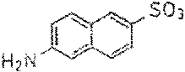
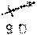

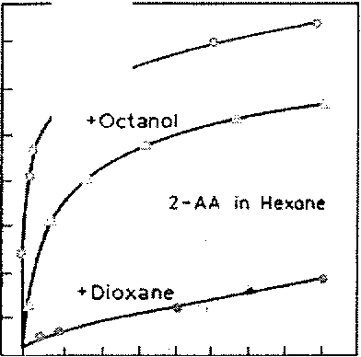
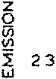
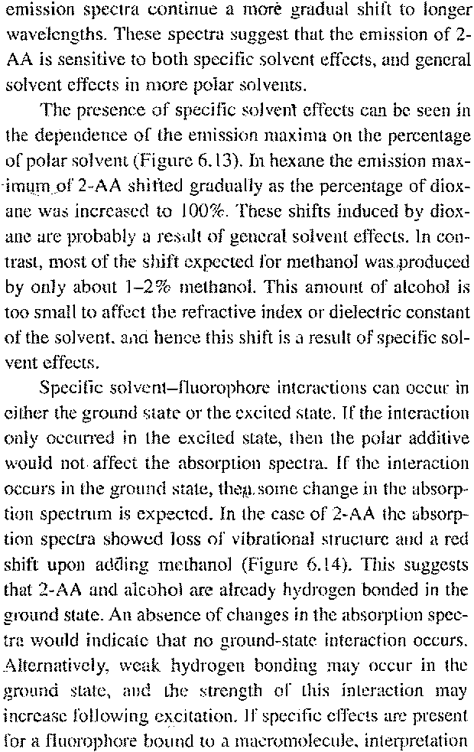
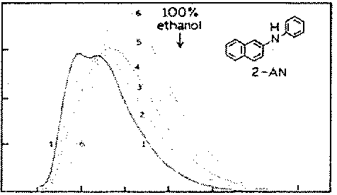
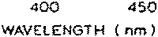
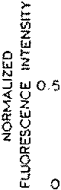
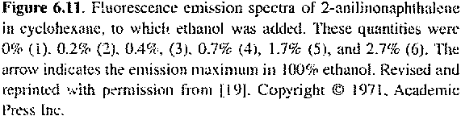
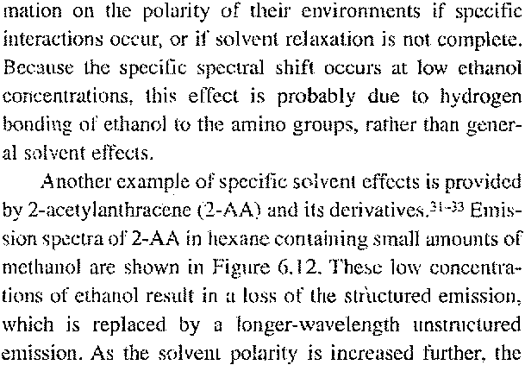
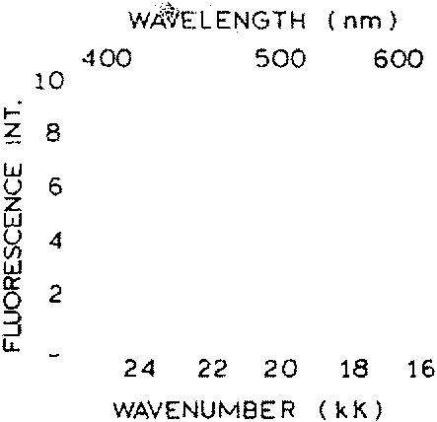
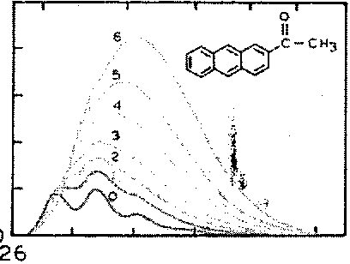
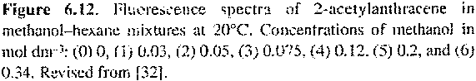

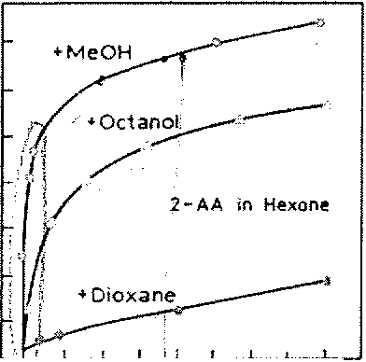
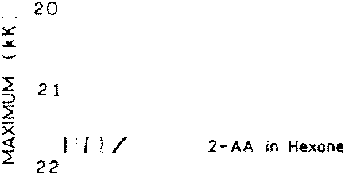
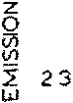
‏ه» ه« 5 ‏« ه« لا
‏ا»ءد.هد ء 05 ‏» 5 ‏ه 0
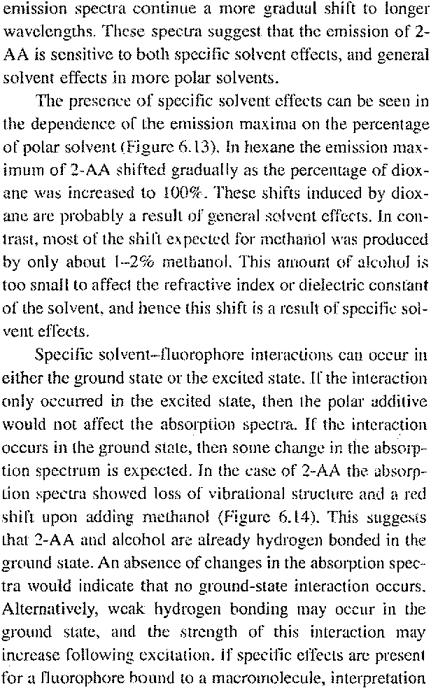
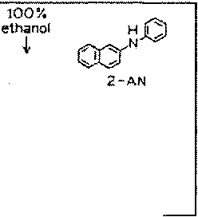
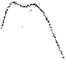
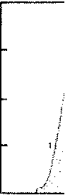
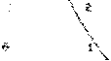
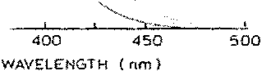
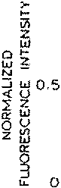
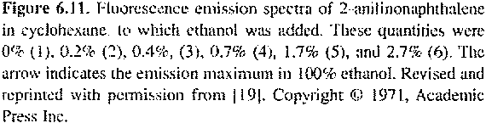
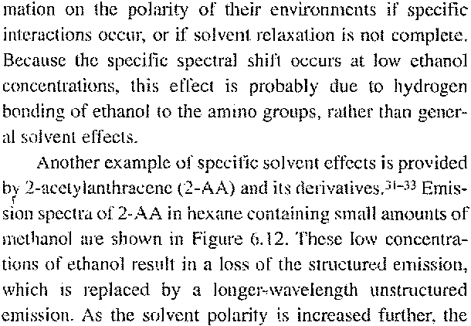
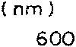
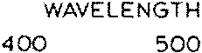
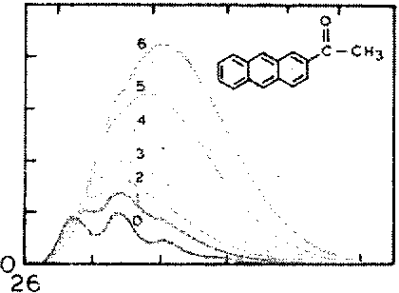
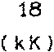
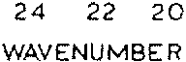
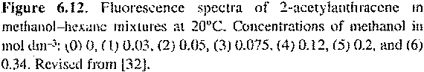

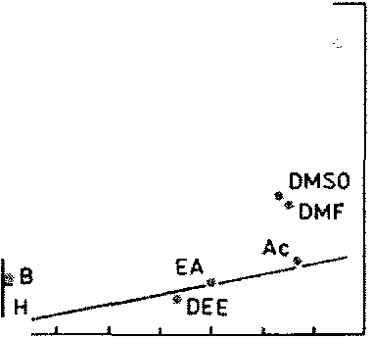
‏ب»وروب و
‏كل لا
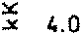
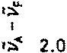
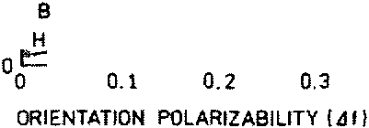
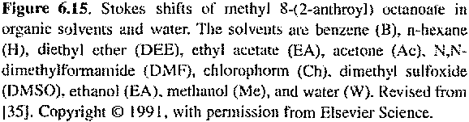
circumstance. it is problematic because these effects can prevent a quantitativc interpretation of the emission spectra in terms of the orientation polarizability of the macrornolecute. The situation is favorable because the specilie effects of protie solvents could reveal the accessibility of the macrornolecule-bound probe to the aqueous phase. Also, specific solvent effects can cause larger and hence move easily observed spectral shifts.
In view of the magititude of specific solvent effects, how can one reliably usc fluorescence spectral data to mdicale the polarity of binding sites? At present there seems to be no completely reliahle method. However, by careful exatnination of the solvent sensitivity of a fluorophore. reasonable estimates can be made. Consider the following hypothetical experiment. Assume that 2-acetylanthracene (2-AA) binds strongly to lipid hilayers so that essentially all the 2-AA is bound to the membratie. It seems likely that, irrespective of the location of 2-AA itt the bilayer, adequate water will be present, either in the ground stnte or during the excited—state lifetime, to result in saturation of the spe— cilic interactions shown in Figures 6.12 to 6.14. Under these conditions the solvent sensitivily of this fluorophore will he best represented by that region of Figttre 6.13 where the concentration of the protic solvent is greater than 10—20%. Note that essentially equivalettt slopes are found within this region for methanol, octanol and dioxane. These similar slopes indicate a similar mechanism, which is the general solvent effect.
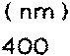
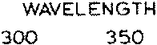
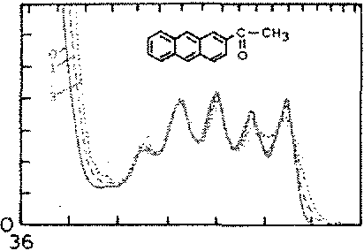
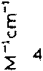
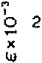
22 ‏» 2 28 28 ‏. 39 32 34 ‏اءددءء ءى»«،«ء 0 ‏~-
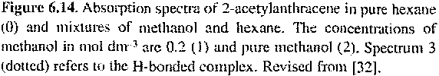
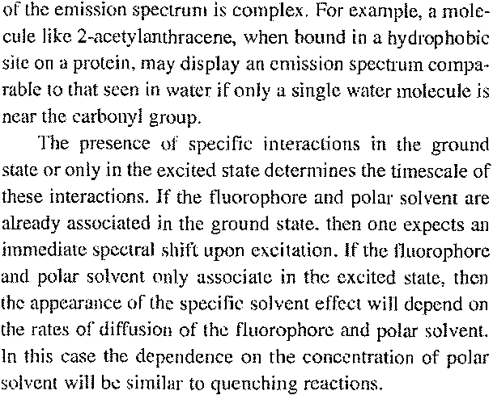
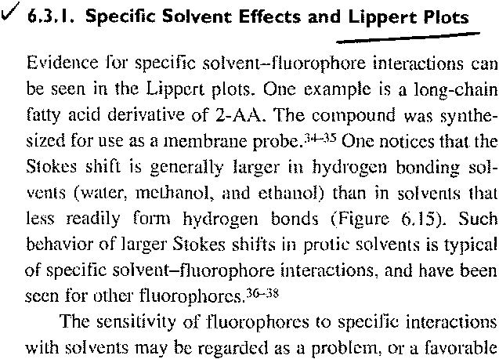


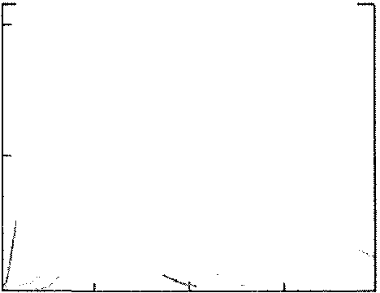
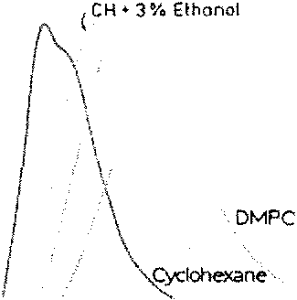
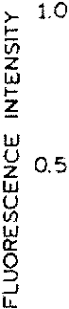
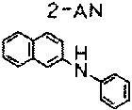
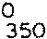
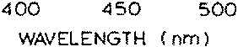
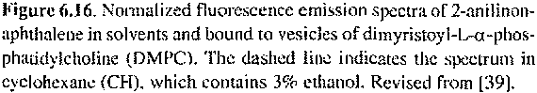
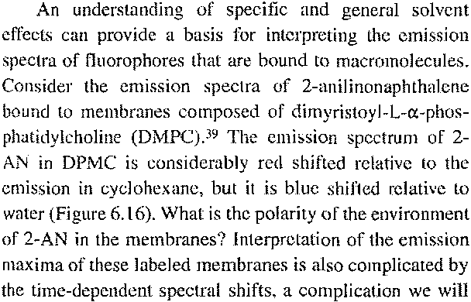
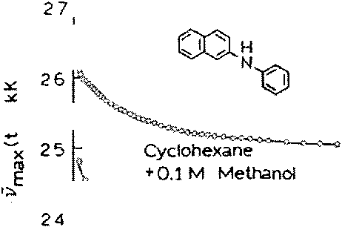
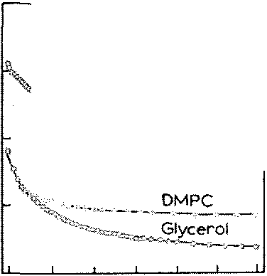
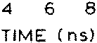

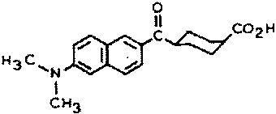
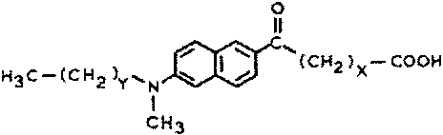
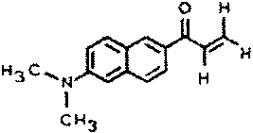
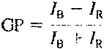
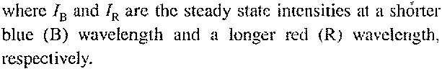
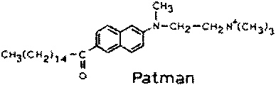
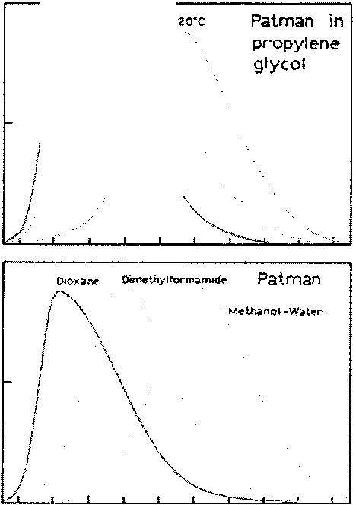
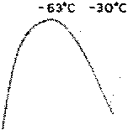
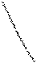
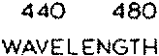
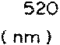
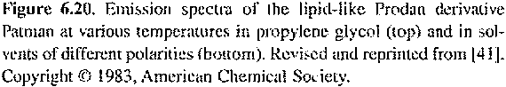
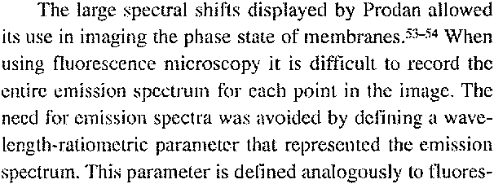
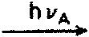

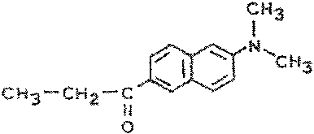
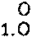

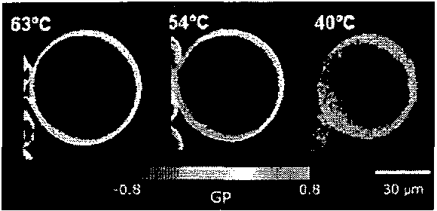
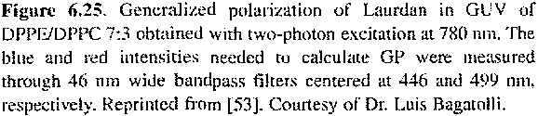
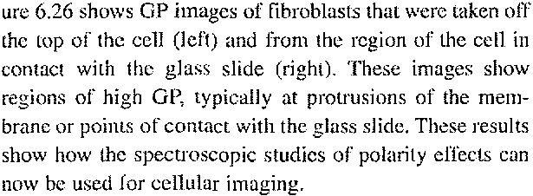
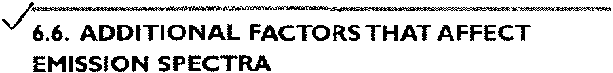
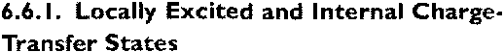
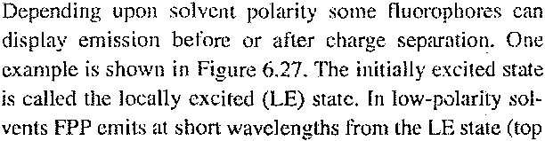
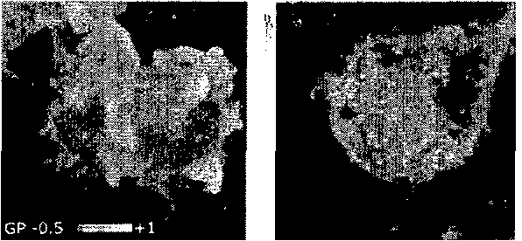
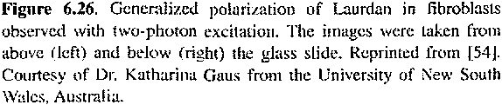
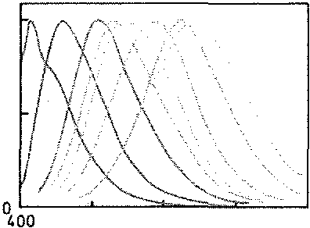
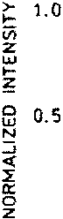
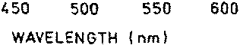
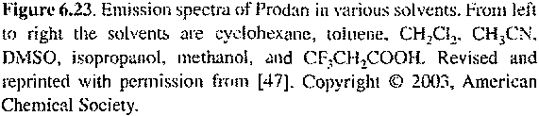
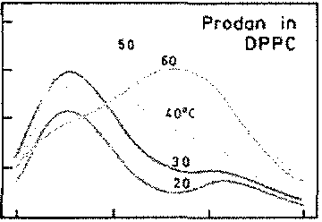
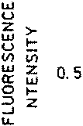
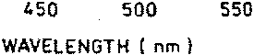
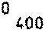
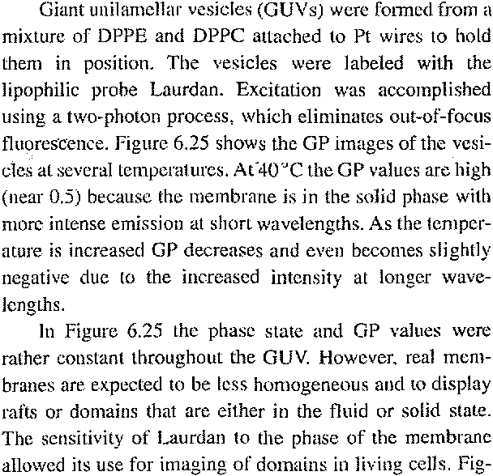





‏ The formation of ICT states indicates that the electron distribution can be different for a fluorophore in the ground or excited states. This can result in changes of ionization in the excited state. One example is intramolecular proton transfer in the excited state, which is referred to as ESIPT. This is shown in the top schematic in Figure 6.30, for the probe FA.⁷⁰ This probe can exist in the normal form (N) or as a tautomer (T). The process of ESIPT can be very rapid because the transferring proton is already next to the proton acceptor at the moment of excitation.
Figure 6.30 shows the emission spectra of FA when dissolved in two nonpolar solvents and when in aqueous solution but bound to BSA. The emission near 525 nm is the N* form, and the emission near 625 nm is the T’ form. FA exhibits very low fluorescence in water. but it is highly fitiorescent when bound to BSA. This high intensity and the sitnilar intensities of the N* and T* forms indicate that FA is in a highly nonpolar environment when bound to BSA. The relative intensities of the N* and Tt emission can be expected to be dependent on the detailed charge and polarity surrounding the fluorophore. as well as its extent of exposure to the aqueous phase. ESIPT occurs in a variety of other fluorophores. ⁶⁸⁻⁷⁷

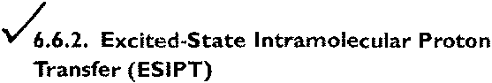

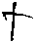

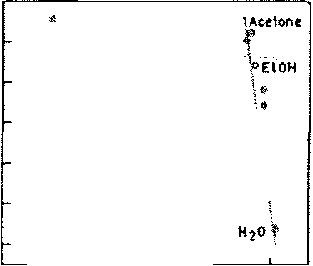
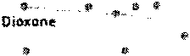
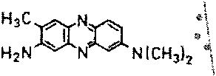
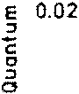
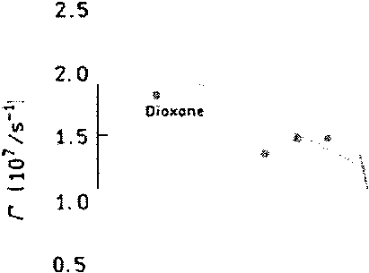
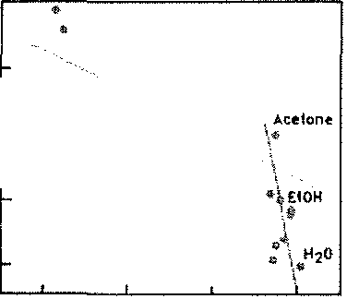
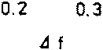
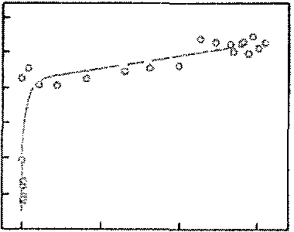
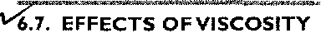
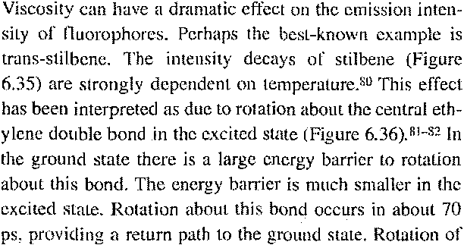
cis—stilbene is even more rapid, resulting in very short fluorescence lifetime. Such rotations in the excited state are thought to affect the emission of many other fluorophores.⁸³
Increase in local viscosity contributes to the increased intensities displayed by many fluorophores when bound to biomolecule. In Chapter I we mentioned the viscosity probe CCVJ, which displayed increases in quantum yield with increases in viscosity. Figure 637 shows the emission intensities of this probe when bound to an antibody directed against this probe.⁸⁴ Binding of CCVJ to the antibody prevents rolation around the ethylene bond and increases the quantum yield.

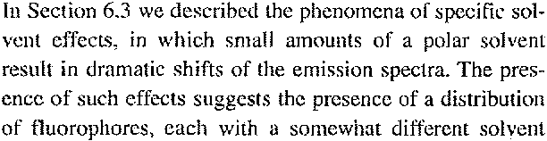
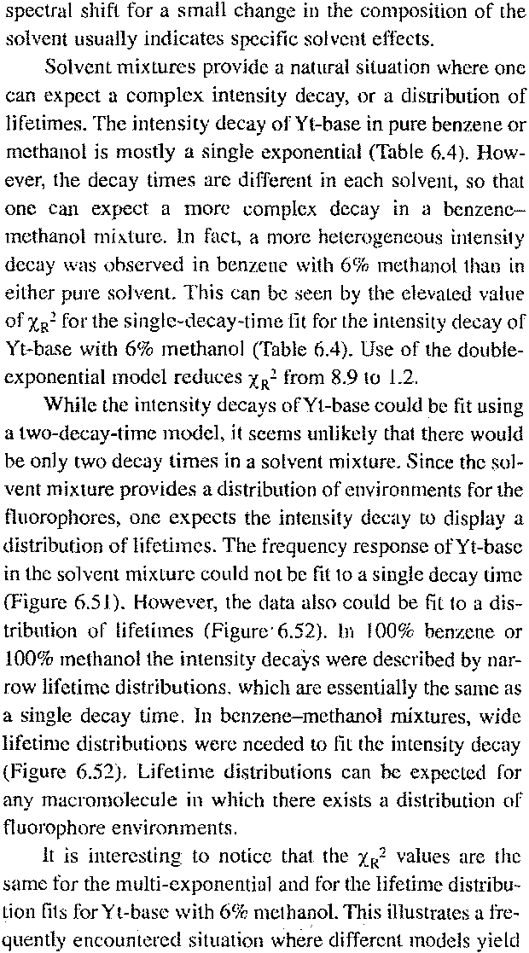
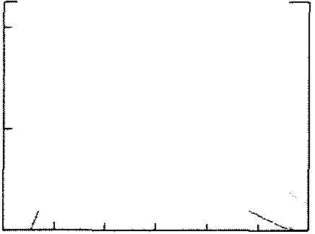
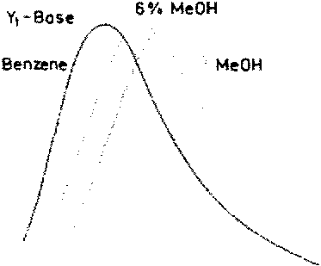
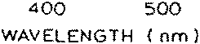
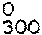
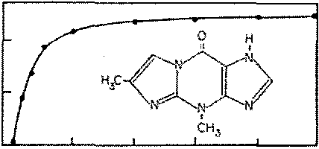
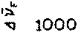
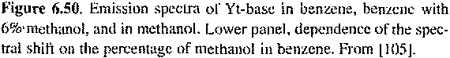
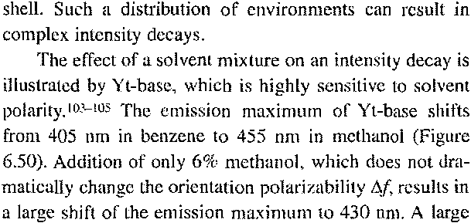

‏_.._.__......_..~ ~._.
‏( «(م لا.~..دم .: . .. ...:لإ.:. 0 ‏~كاا
‏~ • ا: 00 ‏ح ح س ع. لا م
‏ذ. .»دسر؟د،دلمه ،.م رذ
‏~ ء . .:. 48 ‏»لإ«ء_ء.. 8 ‏م
‏!. `رم ء~ 9 ‏لأ لإ
‏.._..:
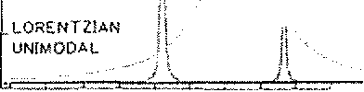
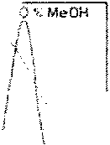
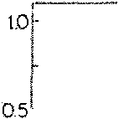
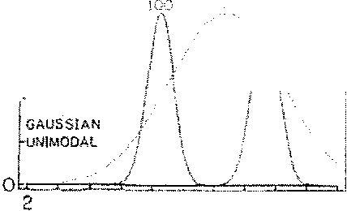
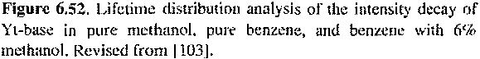
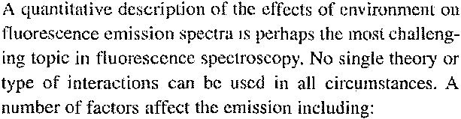
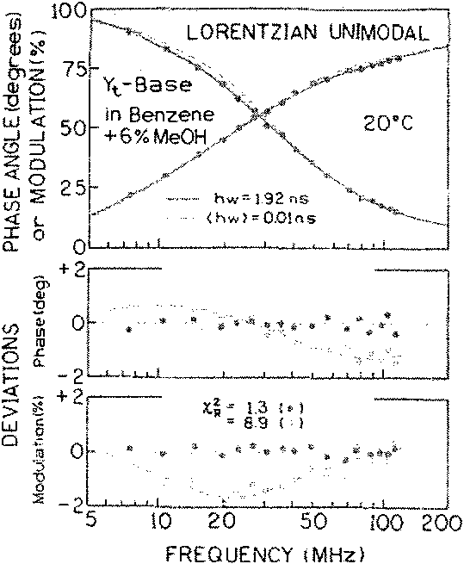
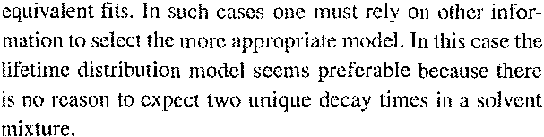
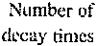
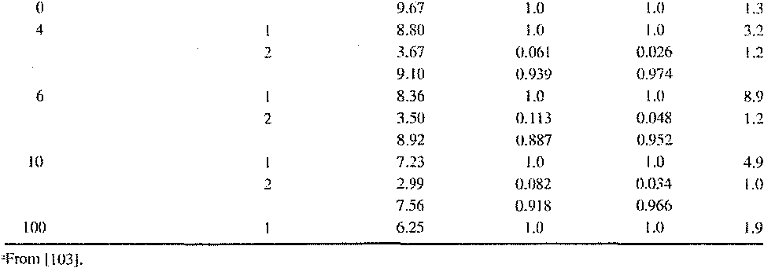
I. General solvent effects due Lot-he interactions of the dipole of the fluorophore with its environment
2. Specific solvent etleeLs due to fluorophore—solvent interactiotls
3. Formation of ICT or TICT states depending on the probe structure and the surrounding solvent
4. Viscosity and changes in the radiative and non- radiative decay rates
5. Probe-probe interactions
- Even if only one type of interaction were present. the eflbcts wottid still be complex and beyond the limits of most models. For instance, the 1_ippert equation is only an approximation, and ignores higher-order ternis. Also, this:
equation only applies 10 a spherical dipole in a spherical cavity. More complex expressions are needed for non- spherical molecules, but one cannot generally describe the tluorophore shape in adequate detail. \Vith regard to specific effects, there is no general theory to predict ihe shift in emission spectra due to hydrogen bond formation And, finally, for Iluorophores bound to inacrotnolecules or in viscotis solvents, spectral relaxation can occur during emission, so that the emission spectrum represenls some weighied average of the um’elaxed and relaxed emission.
Given all these complexities, how can one hope to use the data from solvent sensitive probes? In our opinion, the best approach is to consider the fluorophore structure rather than to ‘clv completely on theory. Observed effects should be considered within the framework of the interactions listed above. Unusual behavior may be due to the presence of mote than one type of interaction. Use the theory as an aid to interpreting plattsible molecular interactions, and not as a substitute for careful consideration probe stntcture and its
likely chernical interactions.

